Submitted by:

IEEE Summer Research Internship Report

on

**Application of Machine Learning in Antenna Design**

**Mohd. Danish Khursheed**

Dept of Electronic Engineering

Zakir Hussain College of

Engineering & Technology, AMU

Mentored by:

**Mr. Md. Azharuddin**

Research Scholar

Department of Electronics & Electrical Communication Engineering Indian Institute of Technology, Kharagpur

Period of Internship

27 July, 2020-28 Aug 2020

Table of Contents

# Introduction 6

How Does an Antenna Work? 7

Different Antenna Designs 8

# Machine Learning & Deep Learning 9

Different Types of Machine Learning 10

Different Types of Deep Learning 11

Machine Learning Vs Deep Learning 13

# Machine Learning in Antenna Design 14

Challenges in application of machine learning 16

Conclusion 16

References 17

## Declaration

This is to certify that the internship report comprises of original work (except where indicated) carried out by me and due acknowledgments have been made in the text to all other material used. The report does not contain any classified information which will be detrimental to national security and is not submitted in any form for another degree or diploma at any other institute/university.

Mohd. Danish Khursheed

## Abstract

With the growth of machine learning and artificial intelligence in general, no field is left untouched by its impact, antenna designing is no different. This report investigates the possible areas where machine learning will be able to give efficient boost to the conventional methods of designing. It also gives broad overview of the different algorithm currently available of machine learning and deep learning to deal with the problems faced during antenna designing.

## INTRODUCTION

As the human species evolved, the need for communicating over larger and larger distance became more and more obvious and absolutely necessary. As a result, some remarkable inventions and discoveries were made in the field of communication, one such invention was that of “Antenna”. The first antennas were built in 1888 by German physicist Heinrich Hertz in his pioneering experiments to prove the existence of waves predicted by the electromagnetic theory of James Clerk Maxwell. *[source: Wikipedia].*

Since then antennas have been significantly modified and have found their applications in several fields ranging from daily mobile communication to satellite communications.

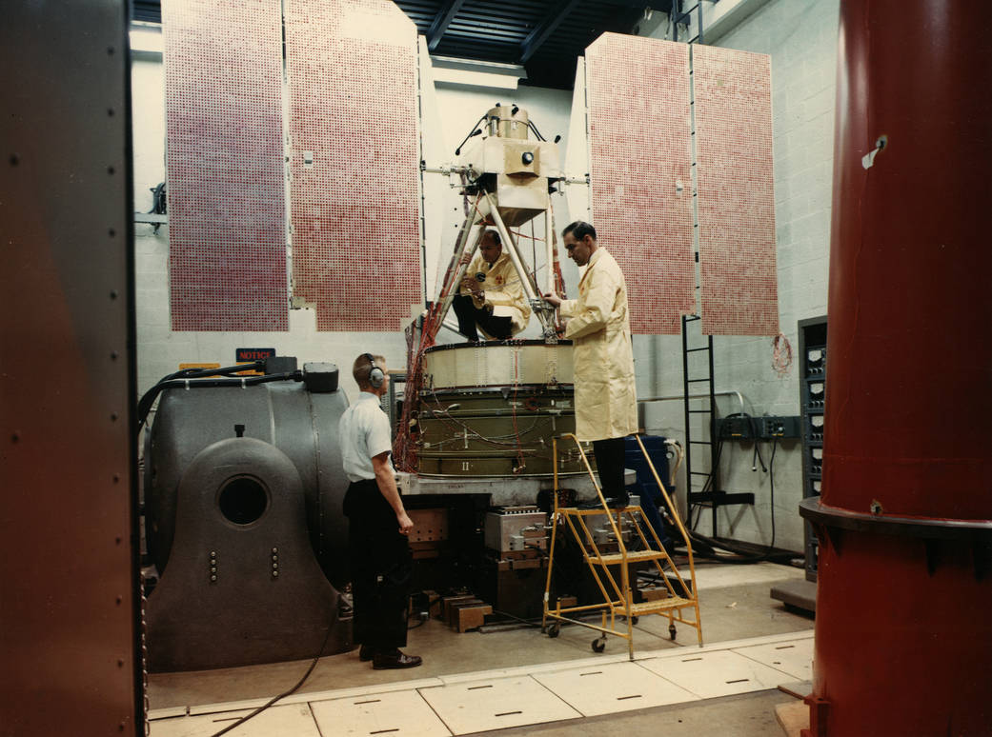

Fig. 1.1 – March 1962, first antenna for the satellite tracking

and data acquisition network (STADAN) *[source: NASA]*

### How does an antenna WORK? :

The antenna at the transmitter generates the radio wave. A voltage at the desired frequency is applied to the antenna. The voltage across the antenna elements and the current through them create the electric and magnetic waves, respectively. At the receiver, the electromagnetic wave passing over the antenna induces a small voltage. Thus, the antenna becomes the signal source for the receiver input.

Transmitter and receiver antennas are often very similar in design. For example, if you're using something like a satellite phone that can send and receive a video-telephone call to any other place on Earth using space satellites, the signals you transmit and receive all pass through a single satellite dish—a special kind of antenna shaped like a bowl (and technically known as a parabolic reflector, because the dish curves in the shape of a graph called a parabola). Often, though, transmitters and receivers look very different. TV or radio broadcasting antennas are huge masts sometimes stretching hundreds of meters/feet into the air, because they have to send powerful signals over long distances. But you don't need anything that big on your TV or radio at home: a much smaller antenna will do the job fine.

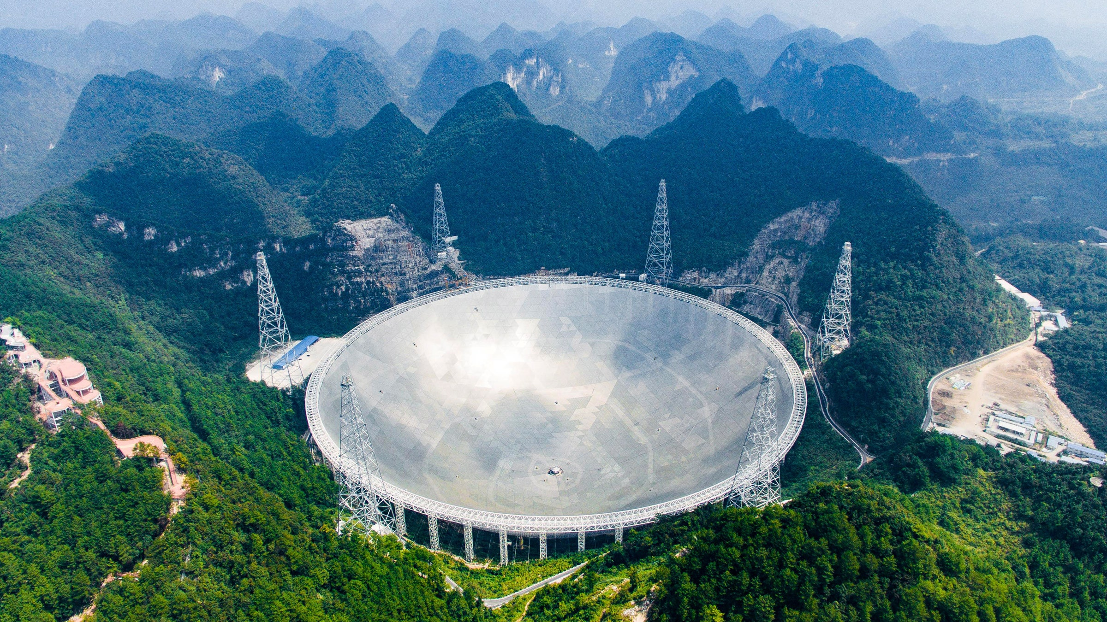

Fig. 1.2 – World’s largest antenna, China Sky Eye *[source: Science Mag]*

### 1.2 Different antenna DESIGNS:

Most modern transistor radios have at least two antennas. One of them is a long, shiny telescopic rod that pulls out from the case and swivels around for picking up FM (frequency modulation) signals. The other is an antenna inside the case, usually fixed to the main circuit board, and it picks up AM (amplitude modulation) signals.

The simplest radio antennas are just long straight rods. Many indoor TV antennas take the form of a dipole: a metal rod split into two pieces and folded horizontally so it looks a bit like a person standing straight up with their arms stretched out horizontally. More sophisticated outdoor TV antennas have a number of these dipoles arranged along a central supporting rod. Other designs include circular loops of wire and, of course, parabolic satellite dishes. Why so many different designs? Obviously, the waves arriving at an antenna from a transmitter are exactly the same, no matter what shape and size the antenna happens to be. A different pattern of dipoles will help to concentrate the signal so it's easier to detect. That effect can be increased even more by adding unconnected, "dummy" dipoles, known as directors and reflectors, which bounce more of the signal over to the actual, receiving dipoles. This is equivalent to boosting the signal—and being able to pick up a weaker signal than a simpler antenna.

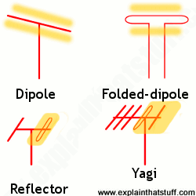

Fig. 1.3 – Different designs of antennas. *[source: Research Gate].*

## 2.Machine Learning & Deep Learning

Machine learning is an application of artificial intelligence (AI) that provides systems the ability to automatically learn and improve from experience without being explicitly programmed. Machine learning focuses on the development of computer programs that can access data and use it learn for themselves. The process of learning begins with observations or data, such as examples, direct experience, or instruction, in order to look for patterns in data and make better decisions in the future based on the examples that we provide. The primary aim is to allow the computers learn automatically without human intervention or assistance and adjust actions accordingly.

Deep learning is an artificial intelligence (AI) function that imitates the workings of the human brain in processing data and creating patterns for use in decision making. Deep learning is a subset of machine learning in artificial intelligence that has networks capable of learning unsupervised from data that is unstructured or unlabeled. Also known as deep neural learning or deep neural network.

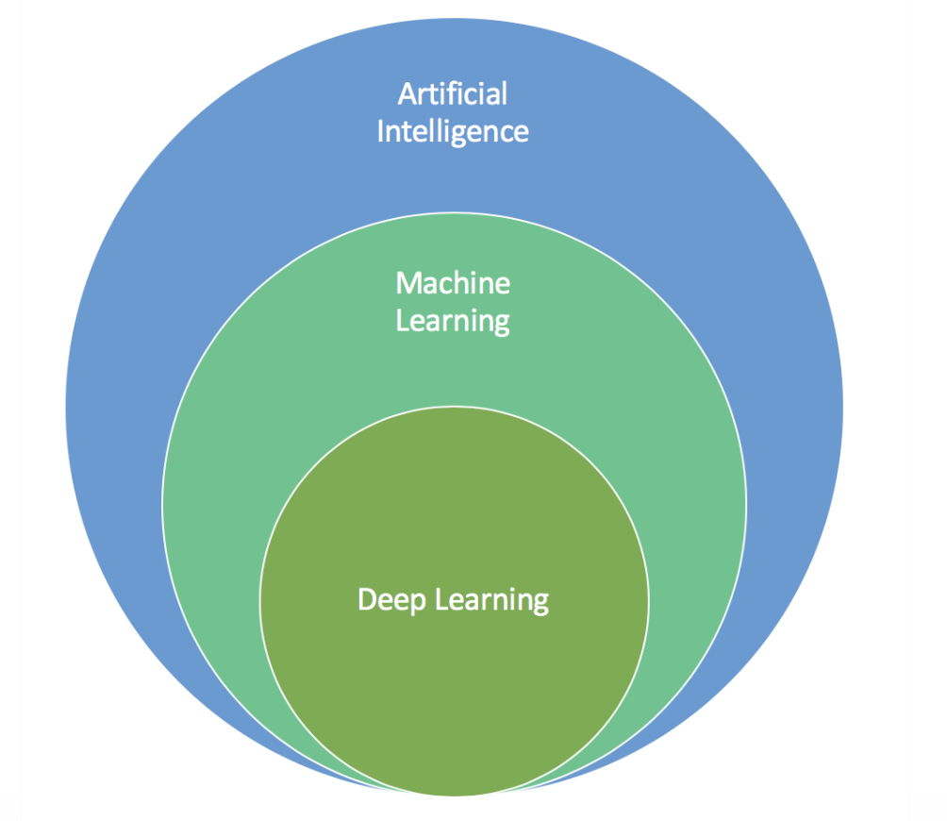

Fig 2.1 – Subsets of Artificial Intelligence *[source: Analytics Vidhya].*

### 2.1 Different Types of machine learning:

* **Supervised machine learning** algorithms can apply what has been learned in the past to new data using labeled examples to predict future events. Starting from the analysis of a known training dataset, the learning algorithm produces an inferred function to make predictions about the output values. The system is able to provide targets for any new input after sufficient training. The learning algorithm can also compare its output with the correct, intended output and find errors in order to modify the model accordingly.
* **Unsupervised machine learning** algorithms are used when the information used to train is neither classified nor labeled. Unsupervised learning studies how systems can infer a function to describe a hidden structure from unlabeled data. The system doesn’t figure out the right output, but it explores the data and can draw inferences from datasets to describe hidden structures from unlabeled data.
* **Semi-supervised machine learning** algorithms fall somewhere in between supervised and unsupervised learning, since they use both labeled and unlabeled data for training – typically a small amount of labeled data and a large amount of unlabeled data. The systems that use this method are able to considerably improve learning accuracy. Usually, semi-supervised learning is chosen when the acquired labeled data requires skilled and relevant resources in order to train it / learn from it. Otherwise, acquiring unlabeled data generally doesn’t require additional resources.
* **Reinforcement machine learning** algorithms is a learning method that interacts with its environment by producing actions and discovers errors or rewards. Trial and error search and delayed reward are the most relevant characteristics of reinforcement learning. This method allows machines and software agents to automatically determine the ideal behavior within a specific context in order to maximize its performance. Simple reward feedback is required for the agent to learn which action is best; this is known as the reinforcement signal.

### 2.2 Different Types of Deep learning:

* **Classic Neural Networks (ANN)** can also be referred to as Multilayer perceptrons. The perceptron model was created in 1958 by American psychologist Frank Rosenblatt. Its singular nature allows it to adapt to basic binary patterns through a series of inputs, simulating the learning patterns of a human-brain. A Multilayer perceptron is the classic neural network model consisting of more than 2 layers.
* **Convolutional Neural Network (CNN)** A more capable and advanced variation of classic artificial neural networks, a CNN is built to handle a greater amount of complexity around pre-processing, and computation of data. CNNs were designed for image data and might be the most efficient and flexible model for image classification problems. Although CNNs were not particularly built to work with non-image data, they can achieve stunning results with non-image data as well. After you have imported your input data into the model, there are 4 parts to building the CNN:

1. Convolution: a process in which feature maps are created out of our input data. A function is then applied to filter maps.

2. Max-Pooling: enables our CNN to detect an image when presented with modification.

3. Flattening: Flatten the data into an array so CNN can read it.

4. Full Connection: The hidden layer, which also calculates the loss function for our model.

* **Recurrent Neural Networks (RNN)** were invented to be used around predicting sequences. LSTM (Long short-term memory) is a popular RNN algorithm with many possible use cases.
* **Autoencoders** work by automatically encoding data based on input values, then performing an activation function, and finally decoding the data for output. A bottleneck of some sort imposed on the input features, compressing them into fewer categories. Thus, if some inherent structure exists within the data, the autoencoder model will identify and leverage it to get the output.

Types/Variations of Autoencoders:

- Sparse Autoencoders: Where the hidden layer is greater than the input layer but a regularization technique is applied to reduce overfitting. Adds a constraint on the loss function, preventing the autoencoder from using all its nodes at a time.

- Denoising Autoencoders: Another regularization technique in which we take a modified version of our input values with some of our input values turned in to 0 randomly.

- Contractive Autoencoders: Adds a penalty to the loss function to prevent overfitting and copying of values when the hidden layer is greater than the input layer.

- Stacked Autoencoders: When you add another hidden layer, you get a stacked autoencoder. It has 2 stages of encoding and 1 stage of decoding.

* **Boltzmann Machine**: In the 4 models above, there’s one thing in common. These models work in a certain direction. Even though SOMs are unsupervised, they still work in a particular direction as do supervised models. Direction here mean:

Input → Hidden Layer → Output.

Boltzmann machines don’t follow a certain direction. All nodes are connected to each other in a circular kind of hyperspace like in the image.

A Boltzmann machine can also generate all parameters of the model, rather than working with fixed input parameters.

Such a model is referred to as stochastic and is different from all the above deterministic models. Restricted Boltzmann Machines are more practical.

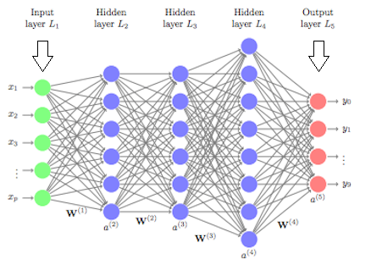

Fig 2.2 – General structure of Artificial Neural Network (ANN)

*[source: Analytics Vidhya]*

### 2.3 Machine learning Vs Deep learning:

The key difference between deep learning vs machine learning stems from the way data is presented to the system. Machine learning algorithms almost always require structured data, whereas deep learning networks rely on layers of the ANN (artificial neural networks). Machine learning algorithms are built to “learn” to do things by understanding labeled data, then use it to produce further outputs with more sets of data. However, they need to be retrained through human intervention when the actual output isn’t the desired one. Deep learning networks do not require human intervention as the nested layers in the neural networks put data through hierarchies of different concepts, which eventually learn through their own errors. However, even these are subject to flawed outputs if the quality of data isn’t good enough. Data is the governor here. It is the quality of data which ultimately determines the quality of the result.

Since machine learning algorithms require labeled data, they aren’t suitable to solve complex queries which involve a huge amount of data. Though in this case, we saw the application of deep learning networks to solve a minor query such as this one. The real application of deep learning neural networks is on a much larger scale. In fact, considering the number of layers, hierarchies, and concepts that these networks process, they are only suited to perform complex calculations rather than simple ones. Both these subsets of AI revolve around data in order to actually deliver any form of “intelligence”. However, what should be known is that deep learning requires much more data than a traditional machine learning algorithm. The reason for this being that it is only able to identify edges (concepts, differences) within layers of neural networks when exposed to over a million data points. Machine learning algorithms, on the other hand, are able to learn through pre-programmed defined criteria.

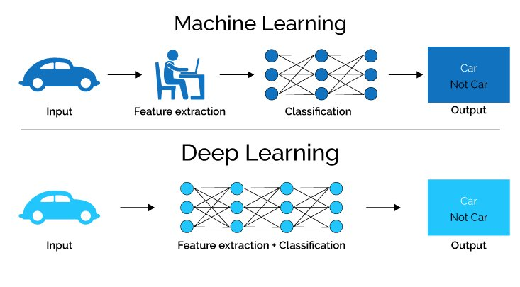

Fig. 2.3 – Machine Learning Vs Deep Learning *[source: Analytics Vidhya]*

## 3.Machine Learning In Antenna Design

Because antenna design is involved with a computationally expensive EM simulator, the simulation time ranges from a few seconds to a few days, depending on the size of the antenna, operating frequency, and computational power. In particular, because the antenna needs to be optimized to maximize the performance while reducing the size, rapid optimization techniques are highly desirable. Rather than using an EM simulator, machine learning algorithms can work as an alternative to the general optimization techniques such as genetic algorithm, particle swarm optimization, and simulated annealing. For example, the relationship between the size of the patch antenna and its resonant frequency is trained by neural networks, allowing the size to be immediately determined through the trained machine. Another approach is to estimate the parameter for the model of the antenna parameter using the machine learning technique. The antenna characteristics, which can be expressed by a mathematical model, can be determined if the model parameters are known Array antenna designs have also been addressed by neural networks

Several papers have investigated the applications of machine learning in antenna design. It is expected that machine learning can provide accelerated antenna design process while maintaining high accuracy levels, with a minimization of error and time saving, along with a possible prediction of the antenna behavior, a better computational efficiency and reduced number of necessary simulations. In general, in order to apply machine learning in antenna

design, the following steps can be done:

1. By multiple simulations, the electromagnetic characteristics of an antenna are found out.
2. These characteristics are stored in a database and used as a data set for training a certain machine learning algorithm.
3. The antenna that gives the closest results is designed by the algorithm after making predictions, depending on the needs of the designer.

### 3.1 Challenges in application of machine learning:

Although Machine Learning is very useful, it comes with a lot of challenges. The most common challenges include but are not limited to:

1. The choice of learning algorithm: It is not easy to decide what algorithm to choose as there are a great number of them. This depends directly on what is being predicted and also on the type of data acquired. A good practice is to always visualize the data before choosing

the algorithm.

1. Problem Formulation: Beginning with wrong assumptions usually lead to worthless results that can cost a lot of time. It is necessary to know what area of the problem is best to spend time working on.
2. Getting enough data: Some data can be hard to find or obtain. In antenna design, multiple simulations are needed in order to obtain a training set.
3. Pre-processing of data: To ensure that the learning algorithm performs adequately, multiple steps need to be performed on the data, such as data cleaning, normalization

and feature selection, which would cost time in case of very large datasets.

1. Debugging the algorithm: Knowing what to do next can also be challenging. When problems, such as high bias and high variance occur, it is crucial to know what

steps to take. This requires following some diagnosis techniques such as plotting the learning curves.

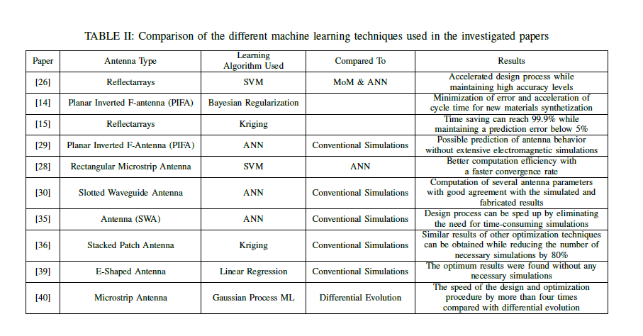

Table 3.1 – Comparing Different Machine Learning Algorithms

*[source: Hilal El Misilmani and Tarek Naous “Machine Learning in Antenna Design: An Overview on Machine Learning Concept and Algorithms”]*

## 4.Conclusion

This report presented an overview on the baseline concepts of antenna designing. Basic working principle of an antenna is also discussed in the starting of the report. Report further deals with general definitions of machine learning and deep learning; it also briefly discusses the different algorithms of machine learning and deep learning respectively. Finally, the application of machine learning in the field of antenna design is discussed along with its limitations. It was seen that machine learning can provide accelerated antenna

design process while maintaining high accuracy levels, with a minimization of error and time saving, along with a possible prediction of the antenna behavior, a better computational efficiency and reduced number of necessary simulations.

## 5. References

1. D. R. Prado, M. Arrebola, M. R. Pino, R. Florencio, R. R. Boix, J. A. Encinar and F. Las-Heras, “Efficient Cross polar Optimization of Shaped- Beam Dual-Polarized Reflect arrays Using Full- Wave Analysis for the Antenna Element Characterization,” IEEE Transactions on Antennas and Propagation, vol. 65, no. 2, pp. 623–635, 2017.
2. Serokell, “Artificial Intelligence vs. Machine Learning vs. Deep Learning: What’s the Difference”, [www.medium.com](http://www.medium.com).
3. Y. Kim, S. Keely, J. Ghosh, and H. Ling, “Application of artificial neural networks to broadband antenna design based on a parametric frequency model,” IEEE Transactions on Antennas and Propagation, vol. 55, pp. 669–674, Mar. 2007.
4. Antenna (radio), from Wikipedia the free encyclopedia, [www.wikipedia.com](http://www.wikipedia.com)
5. Faizan Shaikh, “Deep Learning vs. Machine Learning – the essential differences you need to know!”, [www.analyticsvidhya.com](http://www.analyticsvidhya.com)
6. “First Antenna for the Satellite Tracking and Data Acquisition Network (STADAN) Declared Operational” , [www.nasa.gov](http://www.nasa.gov)
7. M. Lecci, P. Testolina, M. Rebato, A. Testolin, and M. Zorzi, “Machine Learning-aided Design of Thinned Antenna Arrays for Optimized Network Level Performance,” 14th European Conference on Antennas and Propagation (EuCAP 2020), Copenhagen, 2020
8. Youngwook Kim Electrical and Computer Engineering, California State University,

“Application of Machine Learning to Antenna Design and Radar Signal Processing: A Review”, 2018 International Symposium on Antennas and Propagation (ISAP 2018)

October 23~26, 2018 / Paradise Hotel Busan, Busan, Korea.

1. Hilal M. El Misilmani and Tarek Naous, “Machine Learning in Antenna Design: An Overview on Machine Learning Concept and Algorithms”, https://www.researchgate.net/publication/336846687